What is project management?

It feels like a silly question to ask, but it is a very valid question in today’s scenario. A vast majority is still finding it hard to understand what exactly Project Management is. If you have seen some of them most active project management forums, most of the clients raise the same question.

Now, let check what is project management:

Definition

The project management body of knowledge (PMBOK guide) fourth edition by PMI says project management is the application of knowledge, skills, tools and techniques to the project activities to meet project requirements.

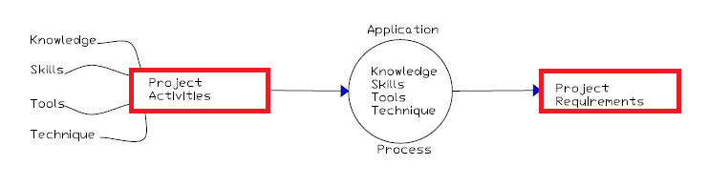

Project management is graphically shown as in the above diagram. We have project activities that are going on and as a result, we produce the project requirements, the scope, and deliverables. We as the project managers will be applying our knowledge, skills, tools, and technique to the project activities. Then this application process will go on to produce the project requirement.

Now let's breakdown certain terms in project management.

Knowledge: Knowledge is what one knows about a particular field, which he or she acquires through education and experience. As most project managers are working on projects involving a specific industry, they tend to acquire specific know how’s relating to that specific industry and this adds to their experience. By educating ourselves about the latest trends and practices in the industry whether it be healthcare, construction, or information technology we can make sure that we always stay ahead of the game.

Skills: Skills are set of specific abilities or the expertise to do something well. It may arise from talent, training, or even acquired through constant practice. For some this might be an innate talent but for the vast majority, the skills that we have in project management can only be sharpened through constant training and practice just like any other sport.

Tools: They are the various instrument or a hand held device that is used to carry out a particular function in project management. Some of the most commonly used tools are the various softwares and applications for example Microsoft excel, primavera, Microsoft project, etc.

Technique: last one is technique. It's a way of carrying out a particular task. It can be methodologies, processes, and frameworks, etc that are required to do a task in project management.

These four components are all used to contribute to the project. The project manager takes a lot to hone these four components. Knowledge, skills, tools, and techniques are the things that project managers actually do to manage the project. This is what project management is all about.

